
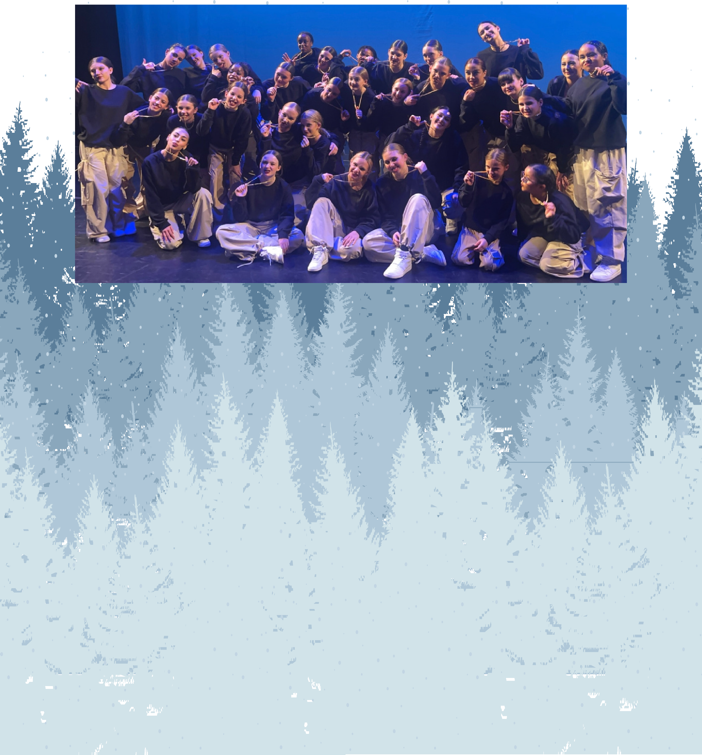
EVQ Dance Presents....

9th Annual Winter Showcase

Sunday, January 5th, 2025 Lone Tree Arts Center Show 1 - 2:00pm



- “Happy Together” - Anna Fiegel, Bella Back, Averly Salem, Briya Breaux, Eliana Fernandez, Elsie
Wininger, Emily Bell, Emmy Ferguson, Evelina
Act 1
Herman, Gretchen Trim, Justine Dzwonkowski, Janet Pelz, Keaton Mitchell, Khaleia Lawrie, Lila
Bunch, LilyThies, Mackenzye Fifield, Melody Crandell, Maxine Seltz, Rylan Rucker, Simone Tkac,
Tessa Martinez

- “Where’s My Love” - BriyaBreaux

- “Funeral” - Anna Fiegel, Bella Back, Eliana Fernandez, Elsie Wininger, Emily Bell, Emmy Ferguson,
Gretchen Trim, Justine Dzwonkowski, Janet Pelz, Jazlyn Martell, Lila Bunch, Mackenzye Fifield, Melody Crandell, Nadia Khan, Simone Tkac, Tessa Martinez

- “World Town” - Abigail Assini, Averly Salem, Briya Breaux, Eileen Bacher, Evelina Herman, Evelyn
McIntyre, Ines Rosenblum, Keaton Mitchell, Khaleia
Act 1
Lawrie, Lily Thies, Maxine Seltz, Rylan Rucker

- “Glimpse” - Emmy Ferguson

- “A Prince” - Mackenzye Fifield

- “Icon” - Abigail Assini, Averly Salem, Briya Breaux, Eliana Fernandez, Emmy Ferguson, Evelina Herman, Ines Rosenblum, Keaton Mitchell, Khaleia Lawrie, Lily
Thies, Rylan Rucker

- “Night In Havana” - Anna Fiegel, Bella Back, Elsie Wininger, Emily Bell, Gretchen Trim, Justine
Dzwonkowski, Janet Pelz, Jazlyn Martell, Lila Bunch, Mackenzye Fifield, Melody Crandell, Nadia Khan,
Act 1
Simone Tkac, Tessa Martinez

- “Doves” - Abigail Assini, Averly Salem, Briya Breaux, Eileen Bacher, Eby Hill, Eliana Fernandez,
Emmy Ferguson, Evelina Herman, Evelyn McIntyre, Hayden Keinreich, Ines Rosenblum, Keaton Mitchell, Khaleia Lawrie, Lily Thies, Maxine Seltz, Rylan Rucker

- “Innocence” - Anna Fiegel



- “Lemme See” - Khaleia Lawrie

- “Downtown” - Anna Fiegel, Bella Back, Averly Salem, Briya Breaux, Eliana Fernandez, Elsie Wininger, Emily Bell,Emmy Ferguson, Evelina Herman, Gretchen
Act 1

Trim, Justine Dzwonkowski, Janet Pelz, Keaton Mitchell,LilaBunch, Lily Thies, Mackenzye Fifield, Melody Crandell, Rylan Rucker, Tessa Martinez

-Intermisson-

- “Sleeping Beauty” - Anna Fiegel, Averly Salem, Bella Back, Eliana Fernandez, Elsie Wininger, Emily
Bell, EmmyFerguson, Gretchen Trim, Janet Pelz,
Act 2
Justine Dzwonkowski, Jazlyn Martell, Keaton Mitchell, Khaleia Lawrie, Lila Bunch, Mackenzye Fifield, Melody Crandell, Nadia Khan, Simone Tkac, Tessa Martinez

- “That Girl” - Rylan Rucker

- “Lydia” - Anna Fiegel, Elsie Wininger, Emily Bell, Gretchen Trim, Janet Pelz, Jazlyn Martell, Lila Bunch,
Melody Crandell, Nadia Khan, Tessa Martinez

- “Missy” - Abigail Assini, Averly Salem, Briya Breaux, Eliana Fernandez, Emmy Ferguson, Evelina Herman, Ines Rosenblum, Keaton Mitchell, Khaleia
Lawrie, Lily Thies, Maxine Seltz, Rylan Rucker
Act 2

- “Edge of Seventeen” - Anna Fiegel, Bella Back, Elsie Wininger, Emily Bell, Gretchen Trim, Janet Pelz, Justine Dzwonkowski, Jazlyn Martell, Lila Bunch,
Mackenzye Fifield, Melody Crandell, Nadia Khan, Simone Tkac, Tessa Martinez

- “Everybody” - Abigail Assini, Averly Salem, Briya Breaux, Eileen Bacher, Eby Hill, Eliana Fernandez, Emmy Ferguson, Evelina Herman, Evelyn McIntyre, nes Rosenblum, Keaton Mitchell, Khaleia Lawrie, Lily
Thies, Maxine Seltz, Rylan Rucker

Act 2

- “Contaminated ” - TessaMartinez

- “Muddy Waters” - Abigail Assini, Averly Salem, Briya Breaux, Eliana Fernandez, Emmy Ferguson, Evelina Herman, Evelyn McIntyre, Ines Rosenblum, Keaton Mitchell, Khaleia Lawrie, Lily Thies, Maxine
Seltz, Rylan Rucker

- “Gimme That ” - Bella Back

- “Pick It Up” - Keaton Mitchell

- “Mfor M” - Anna Fiegel, Bella Back, Briya Breaux, Elsie Wininger, Emily Bell, Emmy Ferguson, Gretchen Trim, Janet Pelz, Justine Dzwonkowski, Jazlyn Martell, Lila Bunch, Mackenzye Fifield, Melody Crandell, Nadia
Khan, Simone Tkac, Tessa Martinez
Act 2

- “Wanna Rock” - Evelina Herman

- “The Moment” - Bella Back, Eliana Fernandez, Elsie Wininger, Emily Bell, Emmy Ferguson, Gretchen Trim, Janet Pelz, Justine Dzwonkowski, Mackenzye Fifield,
Simone Tkac, Tessa Martinez



- “Vision” - Jazlyn Martell, Lila Bunch, Melody Crandell, Nadia Khan
Act 2

- “We The Best” - Abigail Assini, Anna Fiegel,Bella Back, Averly Salem, Briya Breaux, Eliana Fernandez, Elsie Wininger, Emily Bell, Emmy Ferguson, Evelina
Herman, Evelyn McIntyre, Gretchen Trim, Jazlyn Martell, Justine Dzwonkowski, Janet Pelz, Keaton
Mitchell, Khaleia Lawrie, Lila Bunch, Lily Theis,
Mackenzye Fifield, Melody Crandell, Maxine Seltz, Nadia Khan, Rylan Rucker, Simone Tkac, Tessa Martinez

Thank you for attending our show today. We appreciate your continued love and support!

