
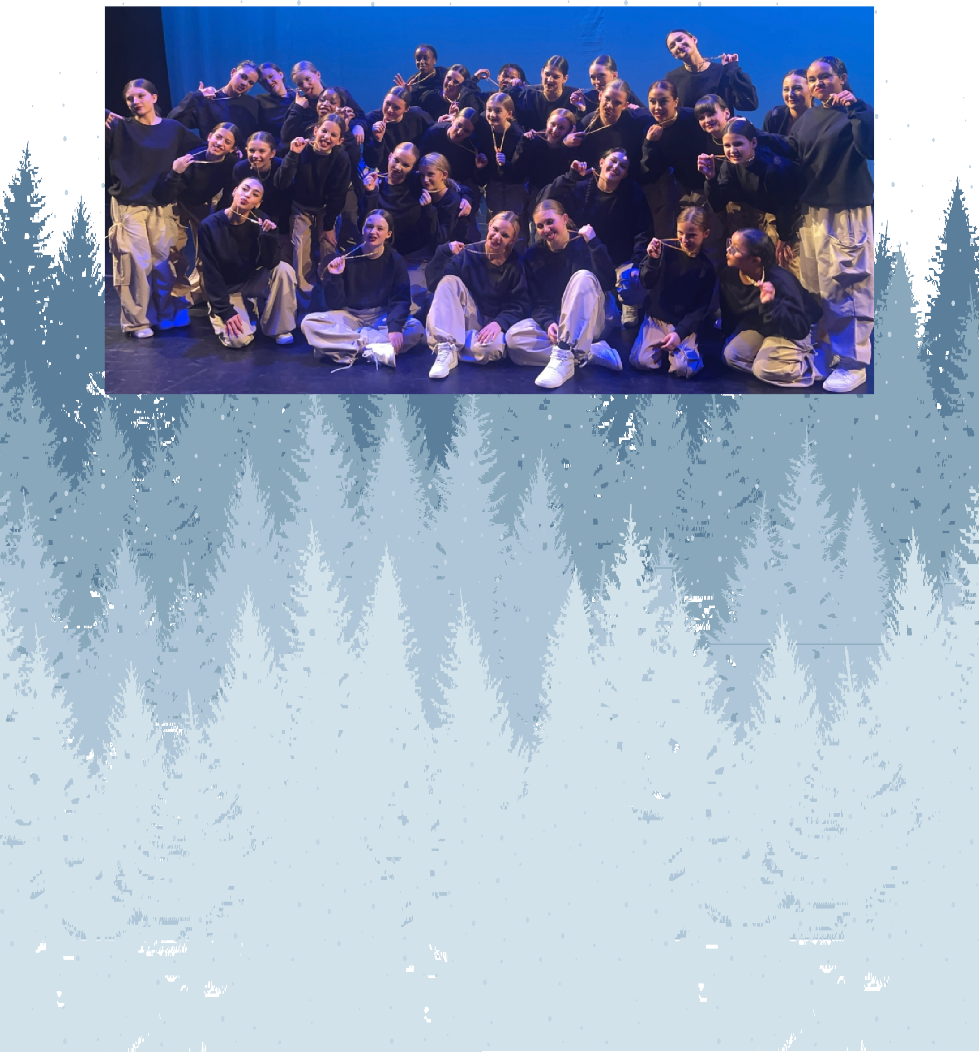
EVQ Dance Presents....

9th Annual Winter Showcase

Sunday, January 5th, 2025 Lone Tree Arts Center Show 2 - 5:30pm



- “Happy Together” - Anna Fiegel, Bella Back, Averly Salem, Briya Breaux, Eliana Fernandez, Elsie
Wininger, Emily Bell, Emmy Ferguson, Evelina
Act 1
Herman, Gretchen Trim, Justine Dzwonkowski, Janet Pelz, Keaton Mitchell, Khaleia Lawrie, Lila
Bunch, LilyThies, Mackenzye Fifield, Melody Crandell, Maxine Seltz, Rylan Rucker, Simone Tkac,
Tessa Martinez

- “Garden” - Jazlyn Martell

- “Knock Knock” - Ines Rosenblum

- “Funeral” - Anna Fiegel, Bella Back, Eliana Fernandez, Elsie Wininger, Emily Bell, Emmy Ferguson,
Gretchen Trim, Justine Dzwonkowski, Janet Pelz, Jazlyn Martell, Lila Bunch, Mackenzye Fifield, Melody Crandell, Nadia Khan, Simone Tkac, Tessa Martinez

- “Safe and Sound” -Lily Thies
Act 1

- “I’d Rather” - Gretchen Trim

- “Icon” - Abigail Assini, Averly Salem, Briya Breaux, Eliana Fernandez, Emmy Ferguson, Evelina Herman, Ines Rosenblum, Keaton Mitchell, Khaleia Lawrie, Lily
Thies, Rylan Rucker

- “One More Shot” - Lila Bunch

- “Play” - Emily Bell

- “Labels Or Love” -Abigail Assini, Averly Salem, Briya Breaux, Eliana Fernandez, Emmy Ferguson,
Act 1
Evelina Herman, Evelyn McIntyre,Ever, Ines
Rosenblum, Keaton Mitchell, Khaleia Lawrie, Lily Thies, Maxine Seltz, Rylan Rucker

- “Night In Havana” - Anna Fiegel, Bella Back, Elsie Wininger, Emily Bell, Gretchen Trim, Justine
Dzwonkowski, Janet Pelz, Jazlyn Martell, Lila Bunch, Mackenzye Fifield, Melody Crandell, Nadia Khan, Simone Tkac, Tessa Martinez



- “Somebody to Love” - Abigail Assini, Averly Salem, Briya Breaux, Eliana Fernandez, Emmy
Ferguson, Evelina Herman, Ines Rosenblum, Keaton Mitchell, Khaleia Lawrie, LilyThies, Rylan Rucker
Act 1

- “Boss” - Maxine Seltz

- “Downtown” - Anna Fiegel, Bella Back, Averly Salem, Briya Breaux, Eliana Fernandez, Elsie Wininger, Emily Bell, Emmy Ferguson, Evelina Herman, Gretchen
Trim, Justine Dzwonkowski, Janet Pelz, Keaton Mitchell, Lila Bunch, Lily Thies, Mackenzye Fifield, Melody Crandell, Rylan Rucker, Tessa Martinez

-Intermisson-

- “Sleeping Beauty” - Anna Fiegel, Averly Salem, Bella Back, Eliana Fernandez, Elsie Wininger, Emily
Bell, EmmyFerguson, Gretchen Trim, Janet Pelz,
Act 2
Justine Dzwonkowski, Jazlyn Martell, Keaton Mitchell, Khaleia Lawrie, Lila Bunch, Mackenzye Fifield, Melody Crandell, Nadia Khan, Simone Tkac, Tessa Martinez

- “Potter Waltz ” - Abigail Assini, Briya Breaux,
Evelina Herman, Ines Rosenblum, Lily Thies, Maxine Seltz, Rylan Rucker

- “Vienna” - Simone Tkac

- “Lydia” - Anna Fiegel, Elsie Wininger, Emily Bell, Gretchen Trim, Janet Pelz, Jazlyn Martell, Lila Bunch,
Melody Crandell, Nadia Khan, Tessa Martinez
Act 2

- “Missy ” - Abigail Assini, Averly Salem, Briya Breaux, Eliana Fernandez, Emmy Ferguson, Evelina Herman, InesRosenblum, Keaton Mitchell, Khaleia
Lawrie, Lily Thies, Maxine Seltz, Rylan Rucker

- “Edge of Seventeen” - Anna Fiegel, Bella Back, Elsie Wininger, Emily Bell, Gretchen Trim, Janet Pelz,
Justine Dzwonkowski, Jazlyn Martell, Lila Bunch, Mackenzye Fifield, Melody Crandell, Nadia Khan, Simone Tkac, Tessa Martinez

- “Muddy Waters” - Abigail Assini, Averly Salem, Briya Breaux, Eliana Fernandez, Emmy Ferguson, Evelina Herman, Evelyn McIntyre, Ines Rosenblum, Keaton Mitchell, Khaleia Lawrie, Lily Thies, Maxine
Act 2
Seltz,RylanRucker

- “Chemtrails ” - Melody Crandell

  - “Color Me ” - Eliana Solo

  - “M for M” - Anna Fiegel, Bella Back, Briya Breaux, Elsie Wininger, Emily Bell, Emmy Ferguson, Gretchen Trim, Janet Pelz, Justine Dzwonkowski, Jazlyn Martell, Lila Bunch, Mackenzye Fifield, Melody Crandell, Nadia
Khan, Simone Tkac, Tessa Martinez

  - “I Am” - NadiaKhan
Act 2

  - “Energia” - Averly Salem

  - “The Moment” - Bella Back, Eliana Fernandez, Elsie Wininger, Emily Bell, Emmy Ferguson, Gretchen Trim, Janet Pelz, Justine Dzwonkowski, Mackenzye Fifield,
Simone Tkac, Tessa Martinez



  - “Vision” - Jazlyn Martell, Lila Bunch, Melody Crandell, Nadia Khan
Act 2

  - “We The Best” - Abigail Assini, Anna Fiegel,Bella Back, Averly Salem, Briya Breaux, Eliana Fernandez, Elsie Wininger, Emily Bell, Emmy Ferguson, Evelina Herman, Evelyn McIntyre, Gretchen Trim, Jazlyn
Martell, Justine Dzwonkowski, Janet Pelz, Keaton Mitchell, Khaleia Lawrie, Lila Bunch, Lily Theis, Mackenzye Fifield, Melody Crandell, Maxine Seltz,
Nadia Khan, Rylan Rucker, Simone Tkac, Tessa Martinez

Thank you for attending our show today. We appreciate your continued love and support!

